**Project Design Phase-II**

**Third-Party API’s**

|  |  |
| --- | --- |
| **Date** | **04 November 2023** |
| **Team ID** | **B65B2412844544AA7B3449CC5696394E** |
| **Project Name** | Implementing CRM for Result Tracking of a Candidate with Internal Marks |

**Third-Party API’s**

Third-party APIs can be valuable resources for enhancing recruiting assistance tools and platforms used by HR managers. These APIs provide access to external services, data, and functionalities that can improve various aspects of the recruitment process. Here are some third-party APIs that can be integrated into recruiting assistance solutions for HR managers:

**LinkedIn Talent Solutions API:** LinkedIn offers APIs that allow HR managers to access candidate profiles, job postings, and recruitment analytics. This API can be integrated into an Applicant Tracking System (ATS) or a recruitment platform to streamline candidate sourcing and management.

**Indeed API:** The Indeed API provides access to job listings, candidate resumes, and job performance data. It can be integrated into recruitment tools to expand job posting capabilities and enhance candidate sourcing.

**Glassdoor API:** Glassdoor offers an API that provides access to company reviews, salary information, and employee insights. Integrating this API can help HR managers research and evaluate potential candidates and employers more effectively.

**CareerBuilder API:** CareerBuilder's API provides access to job listings, applicant data, and other recruitment-related information. It can be used to improve job posting and applicant tracking processes.

**ZipRecruiter API:** The ZipRecruiter API offers job posting and candidate matching capabilities. Integration with this API can help HR managers distribute job listings more widely and identify suitable candidates quickly.

**Background Check APIs:** Various background check providers offer APIs for conducting pre-employment background checks. Integrating such APIs can help HR managers verify candidate credentials and ensure compliance with hiring regulations.

**Onboarding and HRIS APIs**: APIs from onboarding and HRIS (Human Resources Information System) providers can streamline the transition from recruitment to onboarding. These APIs facilitate the transfer of candidate data and employee information, ensuring a seamless onboarding experience.

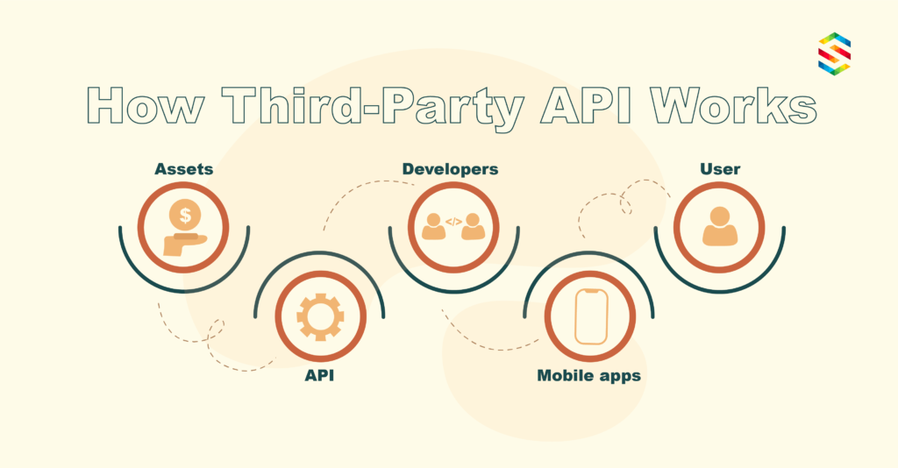

Figure 1.1 : Third party API

**Video Interviewing APIs:** Video interviewing platforms often provide APIs for scheduling, conducting, and reviewing video interviews. Integrating these APIs can enhance the interview process for HR managers.

**Personality Assessment APIs:** Some third-party services offer personality assessment and psychometric testing APIs, which can assist in evaluating candidate suitability and cultural fit.

**Communication APIs (e.g., Twilio, SendGrid)**: Integrating communication APIs can enhance candidate and HR manager communication through automated SMS, email, or chat functionalities, keeping everyone informed throughout the recruitment process.

**AI-Powered Resume Scanning APIs:** These APIs use machine learning to extract information from resumes and CVs, making it easier for HR managers to review and analyze candidate profiles.

**Job Boards APIs:** Many job boards offer APIs to streamline the job posting process. Integrating these APIs can help HR managers post job openings on multiple platforms simultaneously.

**Assessment Tool APIs:** Integration with assessment tool APIs allows HR managers to incorporate skills and personality assessments directly into their recruiting process.

When implementing third-party APIs into recruiting assistance tools for HR managers, it's important to consider factors like data security, compliance with privacy regulations, and the scalability of the API. Additionally, ensure that the API integrates seamlessly with your existing recruitment platform or ATS to provide a unified and efficient experience for HR managers.